**Author : Karthik Thirumoorthi**

**Created On : 24/06/2024**

**Modified On: 25/06/2024**

# **Enhancement Document: Export FastReport Pages to Excel with Separate Sheets**

## **Overview**

**Task ID: 011316**

**Feature: FastReport Export - Option to export FastReport pages to Excel, with each page exported to separate sheets.**

**Version**: 10.8 & 11.3 and above

**Product**: ASBAction , ASBScript

**Requested by**: GI and PayAzzure

## **Requirement**

The enhancement is to allow FastReport data to be exported to Excel such that each data set is printed on a separate sheet within the Excel workbook.

## **Solution Outline**

To achieve the requirement, the following steps must be undertaken:

#### **1. Design the FastReport to Print Data on Separate Pages:**

- Enable the "Start New Page" property for the data band used in the FastReport. This ensures that each data set is printed on a new page in the report.

#### **2. Setup in Axpert:**

- Create a Variable or Tstruct field named 'axp_XLsplittosheet'.

- Set the value of 'axp_XLsplittosheet' to 't'.

### **Detailed Steps**

##### **Step 1: Design the FastReport**

1. Enable "Start New Page" Property:

- Open the FastReport designer.

- Select the data band that contains the data you want to print on separate pages.

- In the properties panel, find the "Start New Page" property and set it to `True`.

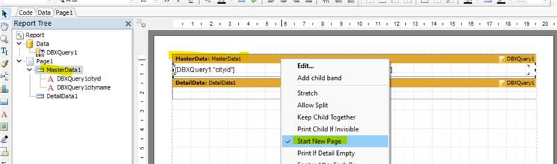

Certainly! Here's an updated section to include the two ways to create `axp_XLsplittosheet` using Axpert:

##### **Step 2: Setup in Axpert**

###### **Option 1: Using Form Field**

**Desktop Version**

**1. Create the Field in the Form:**

- Open the Axpert desktop application.

- Navigate to the relevant form where the report is to be used.

- Add a new field to the form and name it 'axp_XLsplittosheet'.

- Set the default value of this field to 't' or use an expression to set its value to 't'.

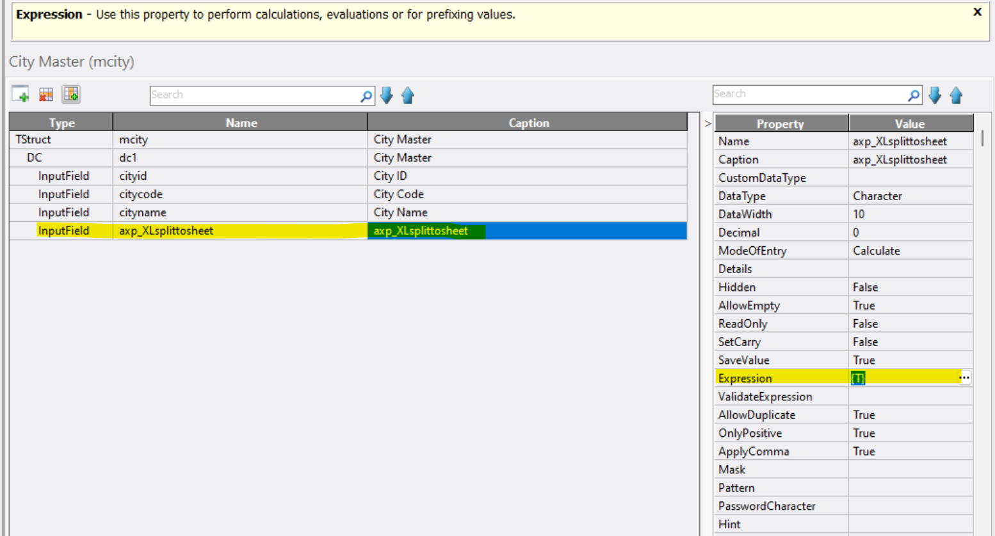

**Web Version (Dev Studio)**

**1. Create the Field in the Form:**

- Open the Axpert web (Dev Studio) interface.

- Navigate to the relevant form where the report is to be used.

- Add a new field to the form and name it 'axp_XLsplittosheet'.

- Set the default value of this field to 't' or use an expression to set its value to 't'.

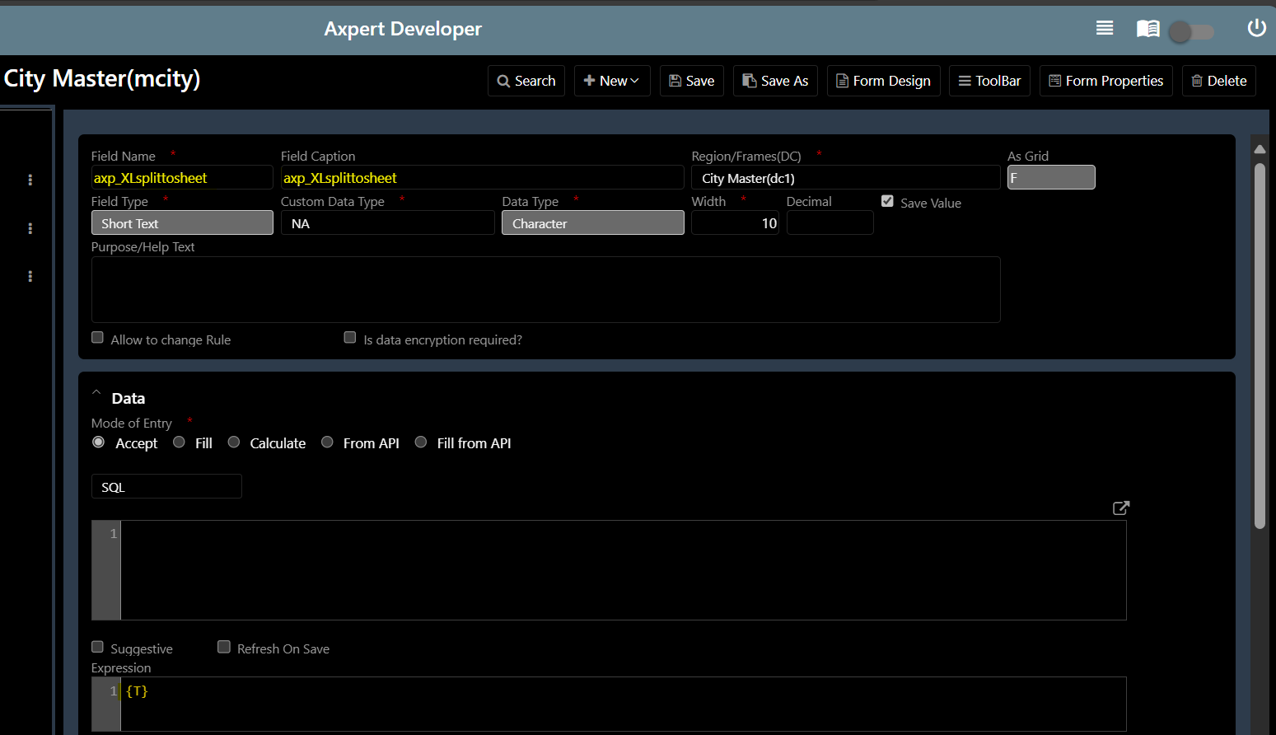

###### **Option 2: Using Axpert Variables (AxVars)**

**Desktop Version**

**1. Create the Variable:**

- Open the Axpert desktop application.

- Go to the AxVars section (Axpert Variables).

- Create a new variable named 'axp_XLsplittosheet'.

- Set the value of this variable to 't'.

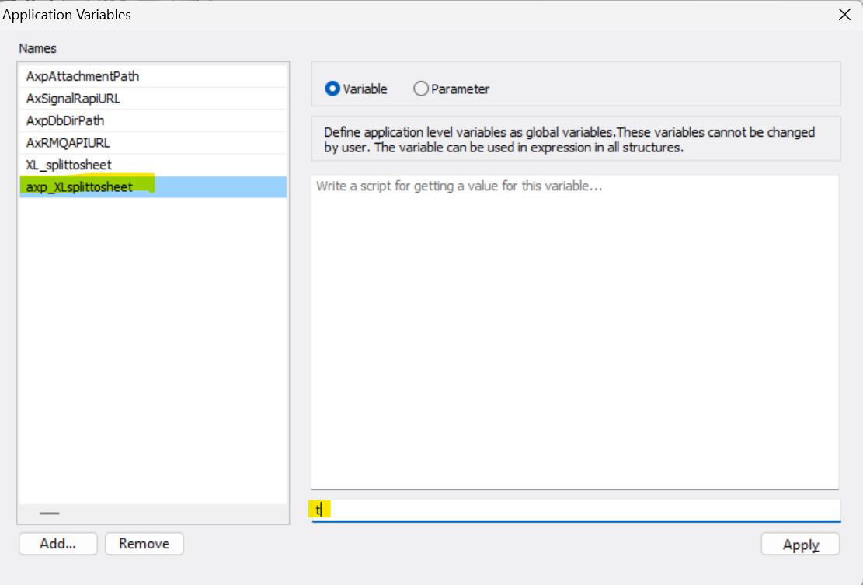

**Web Version (Dev Studio)**

**1. Create the Variable:**

- Open the Axpert web (Dev Studio) interface.

- Go to the AxVars section (Axpert Variables).

- Create a new variable named 'axp_XLsplittosheet'.

- Set the value of this variable to 't'.

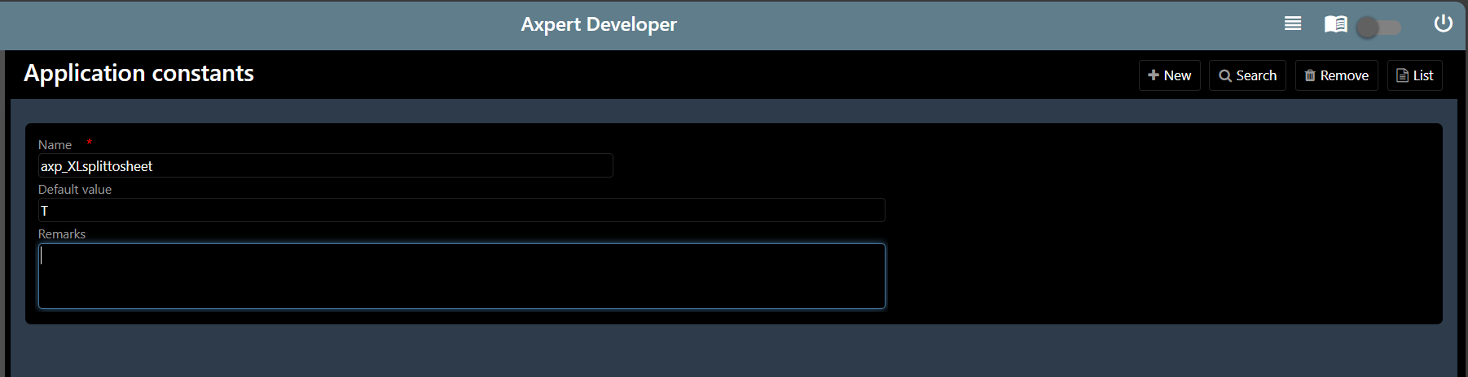

### **Note:**

- Ensure that whichever method you choose, the value of 'axp_XLsplittosheet' is set to 't' to enable the feature of exporting FastReport pages to separate sheets in Excel.

- The value of 'axp_XLsplittosheet' can be set at the form level by creating a field named 'axp_XLsplittosheet' and setting its value accordingly if you want it to apply to a particular form.

Alternatively, it can be defined globally if needed as a global setup by defining 'axp_XLsplittosheet' in Axpert Variables / AxVars.

It is highly recommended to use this variable according to your needs and in the proper way. By default, this will be set to false, and exporting pages to Excel will be exported to a single sheet.

**Additional Note:**

If you have defined the variable globally (in Variables / AxVars) and also defined it in forms, the form variable value will be used. This form variable will overwrite the global variable value when performing any actions at the form level.

Therefore, please use it where necessary and avoid global declaration if not needed.

### **Expected Outcome**

When the above setup is complete, exporting the FastReport to Excel will result in an Excel workbook where each FastReport page is exported to a separate sheet. This ensures that each data set is neatly organized in its own sheet within the workbook.

### **Testing and Validation**

##### **1. Design Verification:**

- Verify that the FastReport correctly prints each data set on a new page when previewed.

##### **2. Functional Testing:**

- Export the FastReport to Excel.

- Confirm that each page of the report appears on a separate sheet within the Excel workbook.

##### **3. Regression Testing:**

- Ensure that the changes do not affect other functionalities of the report export feature.

By following the steps outlined above, the enhancement to export FastReport pages to separate Excel sheets can be successfully implemented. This will fulfill the requirement as requested by GI and PayAzzure.